**Name: ____________________________**

**The immune system**

The body is made up of many body systems working together. For example, the digestive system absorbs nutrients from food. The circulatory system pumps blood around the body to deliver nutrients and remove wastes.

The body system that prevents and fights disease is called the immune system. It is made up of many organs, tissues and cells working together. The immune system fights both infectious diseases, like measles, and non-infectious diseases, like cancer.

The immune system can be described as having **three** lines of defence to protect the body against pathogens.

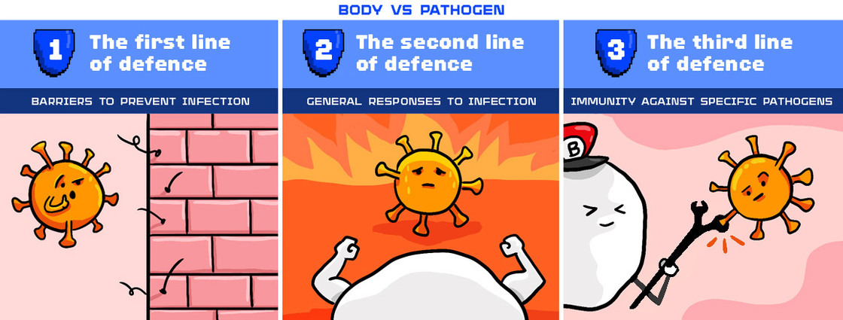

1. What is the role of the immune system?
   1. Absorb nutrients from food.
   2. Deliver nutrients and collect wastes.
   3. Exchange gases, like carbon dioxide and oxygen, with the air.
   4. Prevent and fight disease.
2. How many lines of defence does the immune system have?
   1. 1
   2. 2
   3. 3
   4. 4
3. Some people have a genetic disorder that prevents their immune system from developing normally. Describe the role of the immune system and why people with this disorder are at greater risk of getting sick.

**_____________________________________________________________________________________________________________________________________________________________________________________________________________________________________________________________________________________________________________________________________________________________________________**

**The First line of defence**

The first line of defence is known as the barrier defence. It is non-specific and aims to stop pathogens from entering the body. It is called non-specific because the response is the same regardless of the invading pathogen. Pathogens must make it past the first line of defence before they can cause an infection.

The skin is an effective barrier that covers most of the body. Cuts and grazes are possible sites of infection, which is why first aid is important. Other ways that pathogens can enter the body include the mouth, airways, eyes and urinary tract. Responses such as coughing and vomiting can remove pathogens from the airways or stomach.

Fluids such as saliva, mucus, tears and urine play an important role in the first line of defence. Mucus is a sticky liquid that lines the nose, throat, lungs and intestines. One of its main roles is to protect the body by trapping pathogens. Snot is the mucus produced by a special membrane in the nose. In total, the body produces over 1 litre of mucus every day!

The barriers that make up the first line of defence can be classified as either physical or chemical.

* 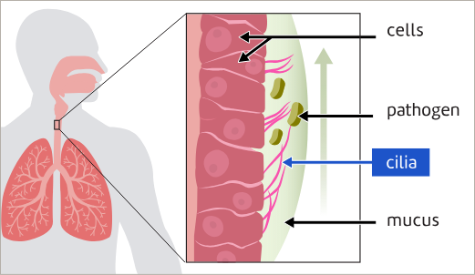**Physical barriers** stop pathogens from entering the body by blocking or trapping them. Examples include skin and mucus. Some physical barriers, like cilia, actively push pathogens out. This is shown in the diagram.
* **Chemical barriers** kill pathogens before they can enter the body. They include stomach acid as well as enzymes in tears, saliva and mucus.

|  |  |
| --- | --- |
| **Defence** | **How it protects against pathogen entry** |
| The skin | The skin covers the whole body. It protects the body from physical damage, microbe infection and dehydration. Its dry, dead outer cells are difficult for microbes to penetrate, and the skin glands produce oils which help kill pathogens. |
| Mucus Membranes | The respiratory system is protected in several ways. Nasal hairs keep out dust and larger microorganisms. Sticky mucus traps dust and pathogens, which are then carried away by cilia - tiny hairs on the cells that line the respiratory system. Tiny hairs called cilia move in a wave-like motion and waft the pathogens and dust particles up to the throat, where they are either coughed or sneezed out or swallowed and then passed out of the body in faeces. |
| Tears | Tears flush pathogens from the eye preventing their entrance into the body. Eyelashes stop large particles entering the eye. |
| Urine | Urine as it flows through the urinary system flushes microbes out of the bladder and urethra. |
| Stomach Acid | Hydrochloric acid in the stomach kills harmful microorganisms that might be in the food or drink that we swallow. |

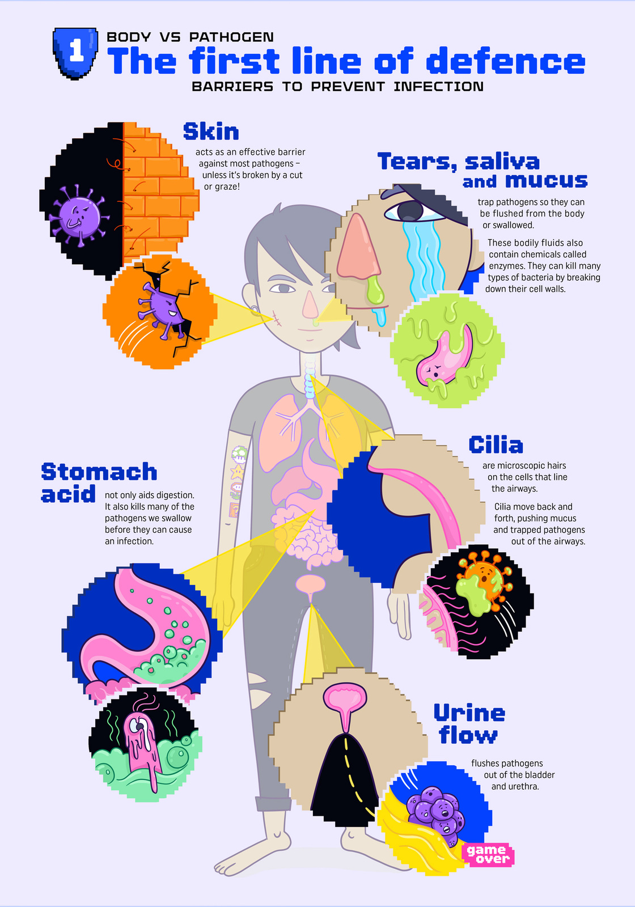

1. What is the role of the first line of defence?
   1. To attack specific pathogens inside the body
   2. To prevent pathogens from entering the body
   3. To respond in a general way to any pathogens that have entered the body
   4. To remember pathogens so they can be quickly defeated in the future
2. Mucus is a sticky liquid. It plays an important role in the first line of defence by trapping pathogens. Which of the following do **NOT** produce mucus?
   1. Nose
   2. Eyes
   3. Lungs
   4. Intestines
3. Cilia are microscopic hairs on the cells that line the airways. What is their role in the first line of defence?
   1. To kill bacteria by breaking down their cell walls
   2. To produce chemicals that can kill pathogens
   3. To push mucus up and out of the airways
   4. To aid the flow of urine out of the bladder and urethra
4. Select the correct ending to complete the sentence. Chemical barriers are those that:
   1. Block pathogens
   2. Trap pathogens in a sticky liquid
   3. Actively push pathogens out
   4. Kill pathogens before they can enter the body
5. Classify these barriers in the first line of defence as either physical, chemical or both.

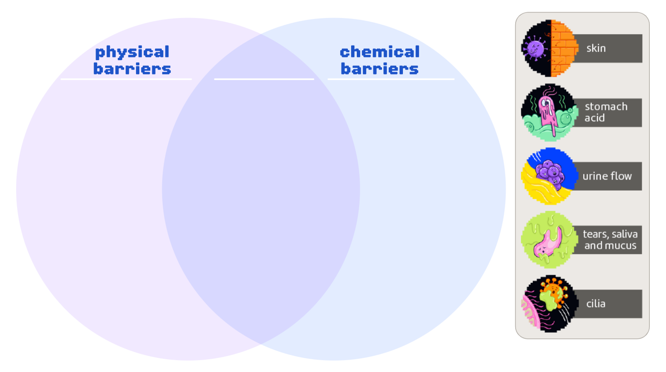

1. Conjunctivitis is a common eye infection also known as “pink eye”. It can be caused by bacteria or viruses and is very contagious. One symptom of conjunctivitis is an increase in the amount of tears produced.

Explain why this might occur. Use the words pathogen, physical barrier, chemical barrier and enzyme.

**____________________________________________________________________________________________________________________________________________________________________________________________________________________________________________________________________________________________________**

1. Tim is eating undercooked chicken nuggets that are contaminated with Salmonella bacteria. However, thanks to his immune system, he does not get infected.

Describe how the first line of defence protects Tim from infection as the nuggets go from his hands to his mouth to his stomach.

**________________________________________________________________________________________________________________________________________________________________________________________________________________________________________________________________________________________________**

**_________________________________________________________________________**

1. Some people with genetic diseases like cystic fibrosis have extremely thick mucus. If mucus is too thick, cilia in the lungs can't push it out.

Explain why this puts people with cystic fibrosis at greater risk of lung infections. Use the words pathogens, physical barrier, lungs and infection in your answer.

**_____________________________________________________________________________________________________________________________________________________________________________________________________________________________________________________________________________________________________________________________________________________________________________**

**How am I feeling about this topic?**

|  |  |  |
| --- | --- | --- |
|  |  |  |
| *I get it!* | *I kinda get it.* | *I don’t get it.* |